Name : Assad Wazeer

Reg No : Fa22-BSE-085

Submitted Date:3-10-23

Assignment : Lab Assignment 2

* 1. **MS SQL Server**

**Step 1:** Download MS-SQL server(any version) for Windows. You can download it from dream spark student’s account as well.

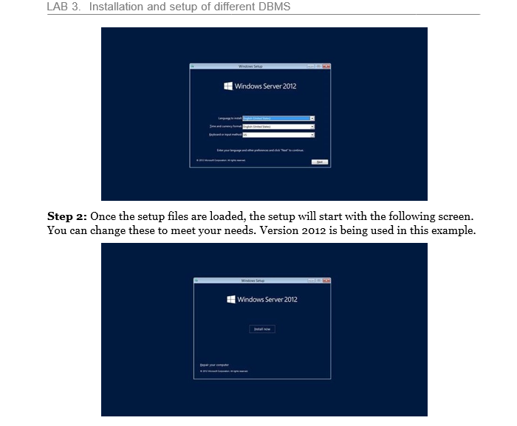

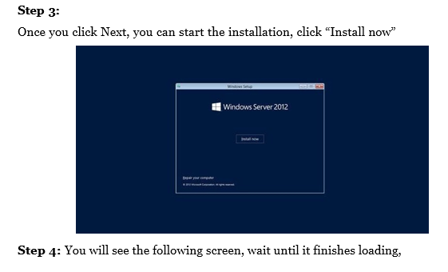

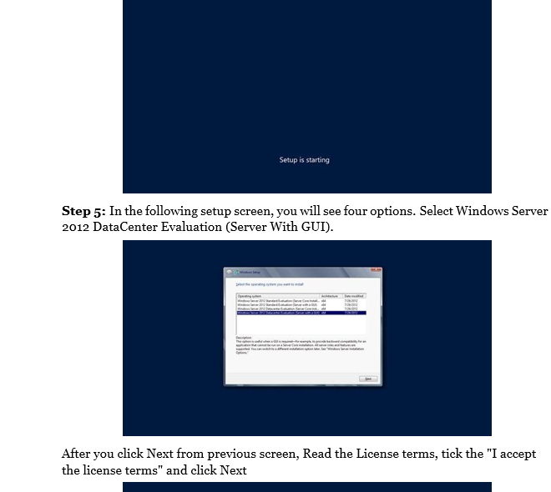

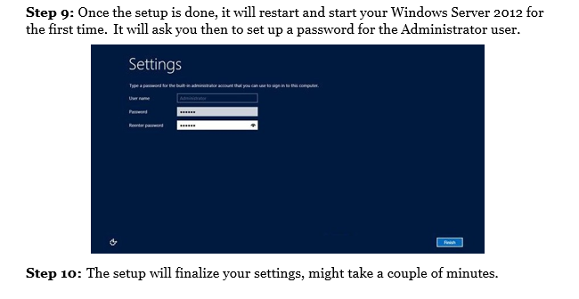 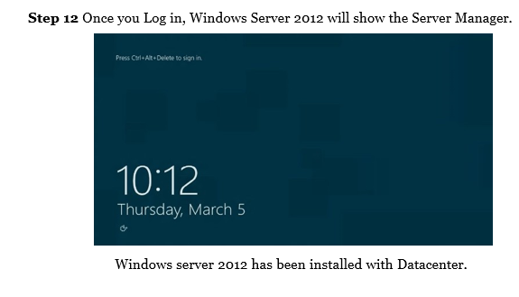

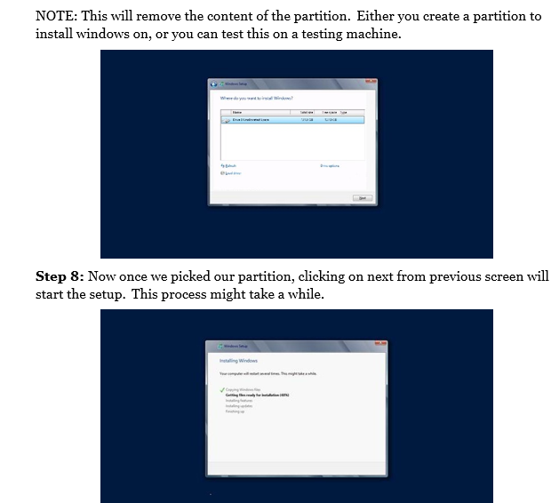

Question: List 2 significance between File Structure And BDMS?

Answer:

• **Data Storage Structure**:

* **File System**: Data is stored in files, often without much structure beyond the file format. Files are managed hierarchically with directories and subdirectories.
* **DBMS**: Data is stored in tables with a well-defined schema. It allows for relational models (or other types like NoSQL) and provides a structured way to manage relationships between different data points.

• **Data Management and Retrieval**:

* **File System**: To retrieve or manipulate data, you usually need to know the file’s location and manually write code to parse and interpret its contents. There’s limited support for complex queries or data manipulation.
* **DBMS**: A DBMS provides a powerful querying language (like SQL) to retrieve, update, and manage data efficiently. It handles complex queries, indexing, and relationships, making data management and retrieval much more flexible and faster.

Question No 3:

Entities in Instagram

• **User**:

* Represents individuals or businesses using Instagram.
* **Attributes**:
  + UserID (unique identifier)
  + Username, FullName, Email, PhoneNumber
  + Bio, ProfilePicture, WebsiteLink
  + FollowersList, FollowingList
  + AccountType (personal, business)
  + PrivacySettings

• **Post**:

* Represents the photos, videos, and other content shared by users.
* **Attributes**:
  + PostID (unique identifier)
  + UserID (who created the post)
  + MediaType (photo, video, reel)
  + MediaURL (link to image or video)
  + Caption, Location
  + LikesCount, CommentsCount
  + Timestamp

• **Comment**:

* Represents comments made by users on posts.
* **Attributes**:
  + CommentID (unique identifier)
  + PostID (the post being commented on)
  + UserID (who made the comment)
  + TextContent, Timestamp
  + LikesCount